Maple Park Middle School Tri-Meet
April 17, 2023
Lakeview, Maple Park, Ray-Pec South
Location: Winnetonka High School
5815 NE 48th Street
Kansas City, MO 64119

Buses: The track is located on the West side of the building. Please drop athletes off at the track, then park on the East side of the building.
Team Seating: When arriving, please choose an area in the bleachers as your team area.
Spectators: No spectators allowed on the track or football field.
Restrooms: Restrooms are located in the entrance to the stadium.
Concessions: Concession stand will not be open, but there will be a Food Truck present.
TIME: All events will begin at 4:00. Coaches Meeting @3:45
Scoring: The first heat will be the scoring heat. Each school is allowed 2 runners in that heat. All other runners should report their times back to their coach. Event points will be 5-3-2-1. Relay points 5-3.
Track: This is a 6 lane all-weather track and runways. 1/8 inch spikes or less.
We would like to ask for additional help in some of the field events. I have indicated which school will be in charge of each field event. In addition, please have a coach available to help with exchange zones.
Field Events (Unlimited Entries):
Shot Put (Ray-Pec South)– Boys followed by Girls –Please take all attempts consecutively
Discus (Maple Park) – Girls followed by Boys – Please take all attempts consecutively
Long Jump (Lakeview) – Cafeteria Style, Boys/Girls Together – 3 attempts
Triple Jump (Maple Park) – Cafeteria Style, Boys/Girls Together – 3 attempts
High Jump (Ray-Pec South)– Girls first opening height 1.2; Boys opening height 1.32
Running Events: (Girls then Boys)
100 M Hurdles
100 M Dash
4 x 200 M Relay
1600 M Run
4 x 100 M Relay
400 M Run
800 M Run
200 M Dash
4 x 400 M Relay

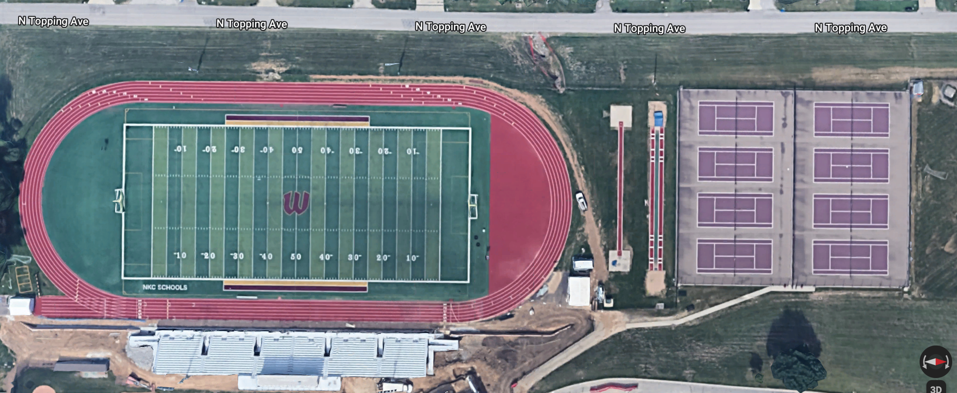
Long Jump
High
Jump
Discus
Triple Jump
Shot Put

